**OpenGL/GLUT Project in code::block**

**step 1: Glut setup**

* Download **glut-3.7.6-bin** from Google
* **Unzip** the file. There will be at least 3 files. (glut.h, glut32.dll, glut32.lib)
* go location : **C:\Program Files (x86)\CodeBlocks\MinGW\include**
* in **GL** folder, paste **glut.h**
* go location: **C:\Program Files (x86)\CodeBlocks\MinGW\lib**, paste **glut32.lib**
* go **C:\Windows\SysWOW64** , paste **glut32.dll**
* **Note: If your Operating System is 32 bit, Folder name might be C:\Windows\System32**

**step 2: Linker settings for Codeblocks**

* Select **settings** -- select **compiler** -- **linker settings**- press **clear**
* press **add**, location: **C:\Program Files (x86)\CodeBlocks\MinGW\lib**
* add: **glut32.lib,** **libglu32.a, libopengl32.a**
* press **ok**
* add: include<GL/gl.h>

**step 3:**  
 Open the code block you will see window as below and click on create new    
 porject link

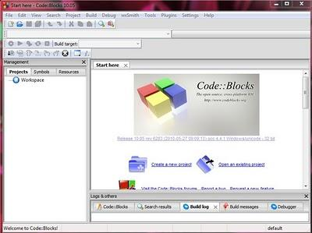

**step 4:**  
click on GLUT project as shown in image below, click next

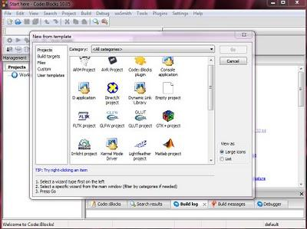

Enter project title name, give path to save project and project file name is created by default from project title name.

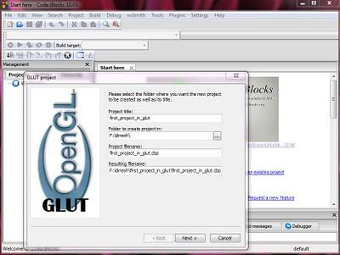

After that click next.  
  
**Step 5:**  
now give the path "C:\Program Files\CodeBlocks\MinGW" for glut location

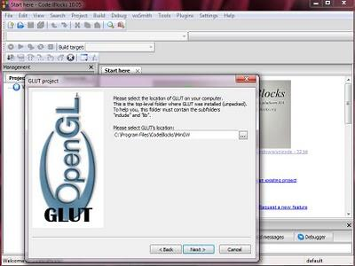

Then click next.

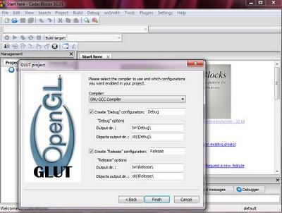

Now click finish

**step 6:**

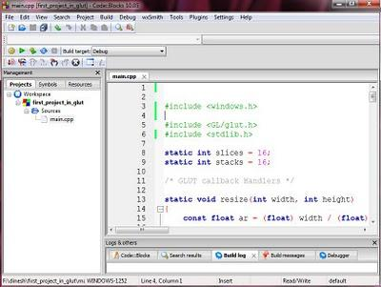

Finally project is created and you will get default main.cpp file and don't forget to write  "#include<GL/gl.h> and #include<windows.h>" header file otherwise you may get error now built and run it will see window as below.

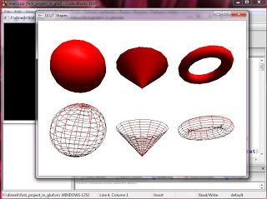

If you see the output of your program as above image then you have successfully   
created a project.